**Project Report**

**The Future of Work : Glassdoor Jobs**

**CONTENTS**

1. INTRODUCTION

1.1 Project Overview

* Briefly introduce the project, its purpose, and the context in which it was developed.

1.2 Purpose

* Explain the main objectives and goals of the project.

1. LITERATURE SURVEY

2.1 Existing Problem

* Describe the problem or challenges that the project aims to address.

2.2 References

* Provide a list of references to relevant literature and sources.

2.3 Problem Statement Definition

* Clearly define the problem statement the project seeks to solve.

1. IDEATION & PROPOSED SOLUTION

3.1 Empathy Map Canvas

* Present an empathy map to understand the target audience and users.

3.2 Ideation & Brainstorming

* Explain the creative process and ideas that led to the proposed solution.

1. REQUIREMENT ANALYSIS

4.1 Functional Requirements

* List the functional requirements of the project.

4.2 Non-Functional Requirements

* Specify the non-functional requirements, such as performance, security, and scalability.

1. PROJECT DESIGN

5.1 Data Flow Diagrams & User Stories

* Provide data flow diagrams and user stories to illustrate how the project works.

5.2 Solution Architecture

* Describe the overall architecture of the project.

1. PROJECT PLANNING & SCHEDULING

6.1 Technical Architecture

* Explain the technical architecture of the project.

6.2 Sprint Planning & Estimation

* Describe the project planning, including sprints and task estimation.

6.3 Sprint Delivery Schedule

* Provide a schedule for the delivery of project milestones.

7. CODING & SOLUTIONING

- In this section, explain the features added in the project along with the code.

1. PERFORMANCE TESTING

8.1 Performance Metrics

- Discuss the performance metrics used to evaluate the project.

1. RESULTS

9.1 Output Screenshots

- Showcase screenshots and visual representations of the project's output.

10. ADVANTAGES & DISADVANTAGES

- Discuss the pros and cons of the project.

11. CONCLUSION

- Summarize the project's key findings and outcomes.

12. FUTURE SCOPE

- Discuss potential future developments and enhancements for the project.

13. APPENDIX

* Include the source code and provide a link to the GitHub repository or project demo.

Source Code

* Include a link to the project's source code repository.

GitHub & Project Demo Link

* Provide a link to the GitHub repository and a demo of the project.

This project report provides a comprehensive overview of "Data Titans Unearthing Trends from LinkedIn Influencers" and should serve as a detailed reference for understanding its development and outcomes.

# 1. INTRODUCTION

## 1.1 Project Overview

Job analysis is a systematic procedure to analyse the requirements for the job role and job profile. Glassdoor is a website and online platform that provides information about jobs, salaries, and companies.

2.1 Existing Problem

In the rapidly evolving landscape of the future of work , the absence of comprehensive data analysis of glassdoor jobs postings presents a pressing challenge . this deficiency hinders both job seekers and employers in navigating the instricies of the job market . the primary problem can be distilled into several .

2.2 References

We referred to various sources, including academic papers, industry reports, and articles, to gain insights into data extraction, text analysis, and social network analysis techniques.

2.3 Problem Statement Definition

The job market is continually evolving, driven by shifts in technology, industry demands, and workforce expectations. Job seekers, employers, and policymakers need a clear understanding of these changes to make informed decisions. However, the lack of in-depth analysis of Glassdoor job postings leaves stakeholders with limited insights into current and emerging job market trends, in-demand skills, and the effectiveness of employer branding strategies. This knowledge gap results in challenges such as job seekers struggling to identify relevant job opportunities, companies facing difficulties in attracting and retaining top talent, and a lack of comprehensive data for informed decision-making. To address these issues, this project aims to conduct a data analysis of Glassdoor job postings to gain valuable insights into the changing landscape of work and employment, providing a foundation for future workforce strategies and decisions.

## 1.2 Purpose

The primary purpose of this project is to extract, analyze, and visualize data fromGlassdoor influencers' profiles and posts to identify emerging trends and topics within specific industries. By doing so, we intend to offer a valuable resource for professionals and businesses seeking to stay updated with the latest industry developments and identify opportunities for growth and collaboration.

| **2.LITERATURE SURVEY**   * 1. **Existing Problem**   The digital landscape is saturated with information, and it can be challenging for professionals to filter through the noise to find relevant and valuable insights.Glassdoor, being a professional network, presents a treasure trove of data, but making sense of this data and extracting meaningful trends is a complex task.   * 1. **References**   We referred to various sources, including academic papers, industry reports, and articles, to gain insights into data extraction, text analysis, and social network analysis techniques.   * 1. **Problem Statement Definition**   The problem we aim to address is how to efficiently extract and analyze data from Glassdoor  Jobs to identify trends and insights that can benefit professionals and organizations.   1. **IDEATION & PROPOSED SOLUTION**    1. **Empathy Map Canvas**   An empathy map was created to understand the needs, pain points, and desires of LinkedIn users, particularly those seeking industry-specific insights.   * 1. **Ideation & Brainstorming**   The project team brainstormed various solutions and settled on developing a web-based platform that would aggregate, analyze, and visualize data from Glassdoors jobs |
| --- |

## 4. REQUIREMENT ANALYSIS

### 4.1 Functional Requirements

| • | Data scraping from LinkedIn profiles and posts |
| --- | --- |
| • | Natural language processing for text analysis |
| • | Trend identification and visualization |
| •  • | User account and preferences management |

### 4.2 Non-Functional Requirements

| • | Security measures for data protection |
| --- | --- |
| • | Scalability to handle a large volume of data |
| • | High-performance computing resources |

## 5. PROJECT DESIGN

**5.1 Data Flow Diagrams & User Stories**

(Data flow diagrams and user stories are included to illustrate the system's design.)

### 5.2 Solution Architecture

The project's architecture includes a web scraping component, data preprocessing, a text analysis module, and a data visualization interface.

## 6. PROJECT PLANNING & SCHEDULING

### 6.1 Technical Architecture

The technical architecture involves using web scraping libraries, natural language processing frameworks, and web development tools.

**6.2 Sprint Planning & Estimation**

The project is divided into sprints with specific tasks and estimated completion times.

**6.3 Sprint Delivery Schedule**

A detailed schedule is provided outlining the expected milestones and delivery dates.

## 7. CODING & SOLUTIONING

### 7.1 Feature 1 – Flask App

<!DOCTYPE html>

<html lang="en">

<head>

<meta charset="utf-8">

<meta content="width=device-width, initial-scale=1.0" name="viewport">

<title>The Future of Jobs - Glassdoor Job Data Analysis</title>

<meta content="" name="description">

<meta content="" name="keywords">

<!-- Favicons -->

<link href="assets/img/favicon.png" rel="icon">

<link href="assets/img/apple-touch-icon.png" rel="apple-touch-icon">

<!-- Google Fonts -->

<link href="https://fonts.googleapis.com/css?family=Open+Sans:300,300i,400,400i,600,600i,700,700i|Krub:300,300i,400,400i,500,500i,600,600i,700,700i|Poppins:300,300i,400,400i,500,500i,600,600i,700,700i" rel="stylesheet">

<!-- Vendor CSS Files -->

<link href="assets/vendor/aos/aos.css" rel="stylesheet">

<link href="assets/vendor/bootstrap/css/bootstrap.min.css" rel="stylesheet">

<link href="assets/vendor/bootstrap-icons/bootstrap-icons.css" rel="stylesheet">

<link href="assets/vendor/boxicons/css/boxicons.min.css" rel="stylesheet">

<link href="assets/vendor/glightbox/css/glightbox.min.css" rel="stylesheet">

<link href="assets/vendor/swiper/swiper-bundle.min.css" rel="stylesheet">

<!-- Template Main CSS File -->

<link href="assets/css/style.css" rel="stylesheet">

<!-- =======================================================

* Template Name: Bikin

* Updated: Sep 18 2023 with Bootstrap v5.3.2

* Template URL: https://bootstrapmade.com/bikin-free-simple-landing-page-template/

* Author: BootstrapMade.com

* License: https://bootstrapmade.com/license/

======================================================== -->

</head>

<body>

<!-- ======= Header ======= -->

<header id="header" class="fixed-top">

<div class="container d-flex align-items-center justify-content-between">

<h1 class="logo"><a href="index.html">Jobysis</a></h1>

<!-- Uncomment below if you prefer to use an image logo -->

<!-- <a href="index.html" class="logo"><img src="assets/img/logo.png" alt="" class="img-fluid"></a>-->

<nav id="navbar" class="navbar">

<ul>

<li><a class="nav-link scrollto active" href="#hero">Home</a></li>

<li><a class="nav-link scrollto" href="#about">About</a></li>

<li><a class="nav-link scrollto" href="#features">Dashboard</a></li>

<li><a class="nav-link scrollto " href="#story">Story</a></li>

<li><a class="nav-link scrollto" href="#team">Team</a></li>

<li><a class="nav-link scrollto" href="#contact">Contact</a></li>

<li><a class="getstarted scrollto" href="#about">Get Started</a></li>

</ul>

<i class="bi bi-list mobile-nav-toggle"></i>

</nav><!-- .navbar -->

</div>

</header><!-- End Header -->

<!-- ======= Hero Section ======= -->

<section id="hero" class="d-flex align-items-center">

<div class="container d-flex flex-column align-items-center justify-content-center" data-aos="fade-up">

<h1>The Future Of Work: Data Analysis Of Glassdoor Jobs</h1>

<h4>lassdoor is a website and online platform that provides information about jobs, salaries, and companies. </h4>

<a href="#about" class="btn-get-started scrollto">Get Started</a>

<img src="assets/img/hero-img.png" class="img-fluid hero-img" alt="" data-aos="zoom-in" data-aos-delay="150">

</div>

</section><!-- End Hero -->

<main id="main">

<!-- ======= About Section ======= -->

<section id="about" class="about">

<div class="container">

<div class="row no-gutters">

<div class="content col-xl-5 d-flex align-items-stretch" data-aos="fade-right">

<div class="content">

<h3>Voluptatem dignissimos provident quasi</h3>

<p>

Lorem ipsum dolor sit amet, consectetur adipiscing elit, sed do eiusmod tempor incididunt ut labore et dolore magna aliqua. Duis aute irure dolor in reprehenderit

</p>

<a href="#" class="about-btn">About us <i class="bx bx-chevron-right"></i></a>

</div>

</div>

<div class="col-xl-7 d-flex align-items-stretch" data-aos="fade-left">

<div class="icon-boxes d-flex flex-column justify-content-center">

<div class="row">

<div class="col-md-6 icon-box" data-aos="fade-up" data-aos-delay="100">

<i class="bx bx-receipt"></i>

<h4>Corporis voluptates sit</h4>

<p>Consequuntur sunt aut quasi enim aliquam quae harum pariatur laboris nisi ut aliquip</p>

</div>

<div class="col-md-6 icon-box" data-aos="fade-up" data-aos-delay="200">

<i class="bx bx-cube-alt"></i>

<h4>Ullamco laboris nisi</h4>

<p>Excepteur sint occaecat cupidatat non proident, sunt in culpa qui officia deserunt</p>

</div>

<div class="col-md-6 icon-box" data-aos="fade-up" data-aos-delay="300">

<i class="bx bx-images"></i>

<h4>Labore consequatur</h4>

<p>Aut suscipit aut cum nemo deleniti aut omnis. Doloribus ut maiores omnis facere</p>

</div>

<div class="col-md-6 icon-box" data-aos="fade-up" data-aos-delay="400">

<i class="bx bx-shield"></i>

<h4>Beatae veritatis</h4>

<p>Expedita veritatis consequuntur nihil tempore laudantium vitae denat pacta</p>

</div>

</div>

</div><!-- End .content-->

</div>

</div>

</div>

</section><!-- End About Section -->

<!-- ======= Features Section ======= -->

<section id="features" class="features" data-aos="fade-up">

<div class="container">

<div class="section-title">

<h2>Dashboard</h2>

<iframe src="https://us3.ca.analytics.ibm.com/bi/?perspective=dashboard&amp;pathRef=.my_folders%2FGlassdoor%2BJobs%2BAnalysis%2BDashboard&amp;closeWindowOnLastView=true&amp;ui_appbar=false&amp;ui_navbar=false&amp;shareMode=embedded&amp;action=view&amp;mode=dashboard&amp;subView=model0000018b8b9eb830_00000000" width="1150" height="900" frameborder="0" gesture="media" allow="encrypted-media" allowfullscreen="" ></iframe>

</div>

<div class="row content">

<div class="col-md-5" data-aos="fade-right" data-aos-delay="100">

<img src="assets/img/features-1.png" class="img-fluid" alt="">

</div>

<div class="col-md-7 pt-4" data-aos="fade-left" data-aos-delay="100">

<h3>Voluptatem dignissimos provident quasi corporis voluptates sit assumenda.</h3>

<p class="fst-italic">

Lorem ipsum dolor sit amet, consectetur adipiscing elit, sed do eiusmod tempor incididunt ut labore et dolore

magna aliqua.

</p>

<ul>

<li><i class="bi bi-check"></i> Ullamco laboris nisi ut aliquip ex ea commodo consequat.</li>

<li><i class="bi bi-check"></i> Duis aute irure dolor in reprehenderit in voluptate velit.</li>

<li><i class="bi bi-check"></i> Ullam est qui quos consequatur eos accusamus.</li>

</ul>

</div>

</div>

<div class="row content">

<div class="col-md-5 order-1 order-md-2" data-aos="fade-left">

</div>

<div class="container" id="story">

<div class="section-title">

<h2>Report</h2>

<iframe src="https://us3.ca.analytics.ibm.com/bi/?pathRef=.my_folders%2FGlass%2FReport&amp;closeWindowOnLastView=true&amp;ui_appbar=false&amp;ui_navbar=false&amp;shareMode=embedded&amp;action=run&amp;format=HTML&amp;prompt=false" width="1150" height="900" frameborder="0" gesture="media" allow="encrypted-media" allowfullscreen=""></iframe>

</div>

</div>

<div class="row content">

<div class="col-md-5" data-aos="fade-right">

<img src="assets/img/features-3.png" class="img-fluid" alt="">

</div>

<div class="col-md-7 pt-5" data-aos="fade-left">

<h3>Sunt consequatur ad ut est nulla consectetur reiciendis animi voluptas</h3>

<p>Cupiditate placeat cupiditate placeat est ipsam culpa. Delectus quia minima quod. Sunt saepe odit aut quia voluptatem hic voluptas dolor doloremque.</p>

<ul>

<li><i class="bi bi-check"></i> Ullamco laboris nisi ut aliquip ex ea commodo consequat.</li>

<li><i class="bi bi-check"></i> Duis aute irure dolor in reprehenderit in voluptate velit.</li>

<li><i class="bi bi-check"></i> Facilis ut et voluptatem aperiam. Autem soluta ad fugiat.</li>

</ul>

</div>

</div>

<div class="row content">

<div class="col-md-5 order-1 order-md-2" data-aos="fade-left">

<img src="assets/img/features-4.png" class="img-fluid" alt="">

</div>

<div class="col-md-7 pt-5 order-2 order-md-1" data-aos="fade-right">

<h3>Quas et necessitatibus eaque impedit ipsum animi consequatur incidunt in</h3>

<p class="fst-italic">

Lorem ipsum dolor sit amet, consectetur adipiscing elit, sed do eiusmod tempor incididunt ut labore et dolore

magna aliqua.

</p>

<p>

Ullamco laboris nisi ut aliquip ex ea commodo consequat. Duis aute irure dolor in reprehenderit in voluptate

velit esse cillum dolore eu fugiat nulla pariatur. Excepteur sint occaecat cupidatat non proident, sunt in

culpa qui officia deserunt mollit anim id est laborum

</p>

</div>

</div>

</div>

</section><!-- End Features Section -->

<!-- ======= Steps Section ======= -->

<section id="steps" class="steps">

<div class="container">

<div class="row no-gutters" data-aos="fade-up">

<div class="col-lg-4 col-md-6 content-item" data-aos="fade-up" data-aos-delay="100">

<span>01</span>

<h4>Lorem Ipsum</h4>

<p>Ulamco laboris nisi ut aliquip ex ea commodo consequat. Et consectetur ducimus vero placeat</p>

</div>

<div class="col-lg-4 col-md-6 content-item" data-aos="fade-up" data-aos-delay="200">

<span>02</span>

<h4>Repellat Nihil</h4>

<p>Dolorem est fugiat occaecati voluptate velit esse. Dicta veritatis dolor quod et vel dire leno para dest</p>

</div>

<div class="col-lg-4 col-md-6 content-item" data-aos="fade-up" data-aos-delay="300">

<span>03</span>

<h4> Ad ad velit qui</h4>

<p>Molestiae officiis omnis illo asperiores. Aut doloribus vitae sunt debitis quo vel nam quis</p>

</div>

<div class="col-lg-4 col-md-6 content-item" data-aos="fade-up" data-aos-delay="100">

<span>04</span>

<h4>Repellendus molestiae</h4>

<p>Inventore quo sint a sint rerum. Distinctio blanditiis deserunt quod soluta quod nam mider lando casa</p>

</div>

<div class="col-lg-4 col-md-6 content-item" data-aos="fade-up" data-aos-delay="200">

<span>05</span>

<h4>Sapiente Magnam</h4>

<p>Vitae dolorem in deleniti ipsum omnis tempore voluptatem. Qui possimus est repellendus est quibusdam</p>

</div>

<div class="col-lg-4 col-md-6 content-item" data-aos="fade-up" data-aos-delay="300">

<span>06</span>

<h4>Facilis Impedit</h4>

<p>Quis eum numquam veniam ea voluptatibus voluptas. Excepturi aut nostrum repudiandae voluptatibus corporis sequi</p>

</div>

</div>

</div>

</section><!-- End Steps Section -->

<!-- ======= Team Section ======= -->

<section id="team" class="team">

<div class="container" data-aos="fade-up">

<div class="section-title">

<h2>Team</h2>

<p>Magnam dolores commodi suscipit. Necessitatibus eius consequatur ex aliquid fuga eum quidem. Sit sint consectetur velit. Quisquam quos quisquam cupiditate. Et nemo qui impedit suscipit alias ea. Quia fugiat sit in iste officiis commodi quidem hic quas.</p>

</div>

<div class="row">

<div class="col-xl-3 col-lg-4 col-md-6" data-aos="fade-up" data-aos-delay="100">

<div class="member">

<img src="assets/img/team/team-1.jpg" class="img-fluid" alt="">

<div class="member-info">

<div class="member-info-content">

<h4>Walter White</h4>

<span>Chief Executive Officer</span>

</div>

<div class="social">

<a href=""><i class="bi bi-twitter"></i></a>

<a href=""><i class="bi bi-facebook"></i></a>

<a href=""><i class="bi bi-instagram"></i></a>

<a href=""><i class="bi bi-linkedin"></i></a>

</div>

</div>

</div>

</div>

<div class="col-xl-3 col-lg-4 col-md-6" data-aos="fade-up" data-aos-delay="200">

<div class="member">

<img src="assets/img/team/team-2.jpg" class="img-fluid" alt="">

<div class="member-info">

<div class="member-info-content">

<h4>Sarah Jhonson</h4>

<span>Product Manager</span>

</div>

<div class="social">

<a href=""><i class="bi bi-twitter"></i></a>

<a href=""><i class="bi bi-facebook"></i></a>

<a href=""><i class="bi bi-instagram"></i></a>

<a href=""><i class="bi bi-linkedin"></i></a>

</div>

</div>

</div>

</div>

<div class="col-xl-3 col-lg-4 col-md-6" data-aos="fade-up" data-aos-delay="300">

<div class="member">

<img src="assets/img/team/team-3.jpg" class="img-fluid" alt="">

<div class="member-info">

<div class="member-info-content">

<h4>William Anderson</h4>

<span>CTO</span>

</div>

<div class="social">

<a href=""><i class="bi bi-twitter"></i></a>

<a href=""><i class="bi bi-facebook"></i></a>

<a href=""><i class="bi bi-instagram"></i></a>

<a href=""><i class="bi bi-linkedin"></i></a>

</div>

</div>

</div>

</div>

<div class="col-xl-3 col-lg-4 col-md-6" data-aos="fade-up" data-aos-delay="400">

<div class="member">

<img src="assets/img/team/team-4.jpg" class="img-fluid" alt="">

<div class="member-info">

<div class="member-info-content">

<h4>Amanda Jepson</h4>

<span>Accountant</span>

</div>

<div class="social">

<a href=""><i class="bi bi-twitter"></i></a>

<a href=""><i class="bi bi-facebook"></i></a>

<a href=""><i class="bi bi-instagram"></i></a>

<a href=""><i class="bi bi-linkedin"></i></a>

</div>

</div>

</div>

</div>

</div>

</div>

</section><!-- End Team Section -->

<!-- ======= Contact Section ======= -->

<section id="contact" class="contact section-bg">

<div class="container" data-aos="fade-up">

<div class="section-title">

<h2>Contact</h2>

<p>Magnam dolores commodi suscipit. Necessitatibus eius consequatur ex aliquid fuga eum quidem. Sit sint consectetur velit. Quisquam quos quisquam cupiditate. Et nemo qui impedit suscipit alias ea. Quia fugiat sit in iste officiis commodi quidem hic quas.</p>

</div>

<div class="row">

<div class="col-lg-6">

<div class="row">

<div class="col-md-12">

<div class="info-box">

<i class="bx bx-map"></i>

<h3>Our Address</h3>

<p>A108 Adam Street, New York, NY 535022</p>

</div>

</div>

<div class="col-md-6">

<div class="info-box mt-4">

<i class="bx bx-envelope"></i>

<h3>Email Us</h3>

<p>info@example.com<br>contact@example.com</p>

</div>

</div>

<div class="col-md-6">

<div class="info-box mt-4">

<i class="bx bx-phone-call"></i>

<h3>Call Us</h3>

<p>+1 5589 55488 55<br>+1 6678 254445 41</p>

</div>

</div>

</div>

</div>

<div class="col-lg-6 mt-4 mt-md-0">

<form action="forms/contact.php" method="post" role="form" class="php-email-form">

<div class="row">

<div class="col-md-6 form-group">

<input type="text" name="name" class="form-control" id="name" placeholder="Your Name" required>

</div>

<div class="col-md-6 form-group mt-3 mt-md-0">

<input type="email" class="form-control" name="email" id="email" placeholder="Your Email" required>

</div>

</div>

<div class="form-group mt-3">

<input type="text" class="form-control" name="subject" id="subject" placeholder="Subject" required>

</div>

<div class="form-group mt-3">

<textarea class="form-control" name="message" rows="5" placeholder="Message" required></textarea>

</div>

<div class="my-3">

<div class="loading">Loading</div>

<div class="error-message"></div>

<div class="sent-message">Your message has been sent. Thank you!</div>

</div>

<div class="text-center"><button type="submit">Send Message</button></div>

</form>

</div>

</div>

</div>

</section><!-- End Contact Section -->

</main><!-- End #main -->

<!-- ======= Footer ======= -->

<footer id="footer">

<div class="footer-top">

<div class="container">

<div class="row">

<div class="col-lg-3 col-md-6 footer-contact">

<h3>Bikin</h3>

<p>

A108 Adam Street <br>

New York, NY 535022<br>

United States <br><br>

<strong>Phone:</strong> +1 5589 55488 55<br>

<strong>Email:</strong> info@example.com<br>

</p>

</div>

<div class="col-lg-2 col-md-6 footer-links">

<h4>Useful Links</h4>

<ul>

<li><i class="bx bx-chevron-right"></i> <a href="#">Home</a></li>

<li><i class="bx bx-chevron-right"></i> <a href="#">About us</a></li>

<li><i class="bx bx-chevron-right"></i> <a href="#">Services</a></li>

<li><i class="bx bx-chevron-right"></i> <a href="#">Terms of service</a></li>

<li><i class="bx bx-chevron-right"></i> <a href="#">Privacy policy</a></li>

</ul>

</div>

<div class="col-lg-3 col-md-6 footer-links">

<h4>Our Services</h4>

<ul>

<li><i class="bx bx-chevron-right"></i> <a href="#">Web Design</a></li>

<li><i class="bx bx-chevron-right"></i> <a href="#">Web Development</a></li>

<li><i class="bx bx-chevron-right"></i> <a href="#">Product Management</a></li>

<li><i class="bx bx-chevron-right"></i> <a href="#">Marketing</a></li>

<li><i class="bx bx-chevron-right"></i> <a href="#">Graphic Design</a></li>

</ul>

</div>

<div class="col-lg-4 col-md-6 footer-newsletter">

<h4>Join Our Newsletter</h4>

<p>Tamen quem nulla quae legam multos aute sint culpa legam noster magna</p>

<form action="" method="post">

<input type="email" name="email"><input type="submit" value="Subscribe">

</form>

</div>

</div>

</div>

</div>

<div class="container d-md-flex py-4">

<div class="me-md-auto text-center text-md-start">

<div class="copyright">

&copy; Copyright <strong><span>Jobysis</span></strong>. All Rights Reserved

</div>

<div class="credits">

<!-- All the links in the footer should remain intact. -->

<!-- You can delete the links only if you purchased the pro version. -->

<!-- Licensing information: https://bootstrapmade.com/license/ -->

<!-- Purchase the pro version with working PHP/AJAX contact form: https://bootstrapmade.com/bikin-free-simple-landing-page-template/ -->

Designed by <a href="https://bootstrapmade.com/">BootstrapMade</a>

</div>

</div>

<div class="social-links text-center text-md-right pt-3 pt-md-0">

<a href="#" class="twitter"><i class="bx bxl-twitter"></i></a>

<a href="#" class="facebook"><i class="bx bxl-facebook"></i></a>

<a href="#" class="instagram"><i class="bx bxl-instagram"></i></a>

<a href="#" class="google-plus"><i class="bx bxl-skype"></i></a>

<a href="#" class="linkedin"><i class="bx bxl-linkedin"></i></a>

</div>

</div>

</footer><!-- End Footer -->

<div id="preloader"></div>

<a href="#" class="back-to-top d-flex align-items-center justify-content-center"><i class="bi bi-arrow-up-short"></i></a>

<!-- Vendor JS Files -->

<script src="assets/vendor/aos/aos.js"></script>

<script src="assets/vendor/bootstrap/js/bootstrap.bundle.min.js"></script>

<script src="assets/vendor/glightbox/js/glightbox.min.js"></script>

<script src="assets/vendor/isotope-layout/isotope.pkgd.min.js"></script>

<script src="assets/vendor/swiper/swiper-bundle.min.js"></script>

<script src="assets/vendor/php-email-form/validate.js"></script>

<!-- Template Main JS File -->

<script src="assets/js/main.js"></script>

<!-- Code injected by live-server -->

<script>

// <![CDATA[ <-- For SVG support

if ('WebSocket' in window) {

(function () {

function refreshCSS() {

var sheets = [].slice.call(document.getElementsByTagName("link"));

var head = document.getElementsByTagName("head")[0];

for (var i = 0; i < sheets.length; ++i) {

var elem = sheets[i];

var parent = elem.parentElement || head;

parent.removeChild(elem);

var rel = elem.rel;

if (elem.href && typeof rel != "string" || rel.length == 0 || rel.toLowerCase() == "stylesheet") {

var url = elem.href.replace(/(&|\?)_cacheOverride=\d+/, '');

elem.href = url + (url.indexOf('?') >= 0 ? '&' : '?') + '_cacheOverride=' + (new Date().valueOf());

}

parent.appendChild(elem);

}

}

var protocol = window.location.protocol === 'http:' ? 'ws://' : 'wss://';

var address = protocol + window.location.host + window.location.pathname + '/ws';

var socket = new WebSocket(address);

socket.onmessage = function (msg) {

if (msg.data == 'reload') window.location.reload();

else if (msg.data == 'refreshcss') refreshCSS();

};

if (sessionStorage && !sessionStorage.getItem('IsThisFirstTime_Log_From_LiveServer')) {

console.log('Live reload enabled.');

sessionStorage.setItem('IsThisFirstTime_Log_From_LiveServer', true);

}

})();

}

else {

console.error('Upgrade your browser. This Browser is NOT supported WebSocket for Live-Reloading.');

}// ]]></script></body></html>

## 8. PERFORMANCE TESTING

### 8.1 Performance Metrics

The project's performance is measured based on data extraction speed, accuracy of trend identification, and system response times.

## 9. RESULTS

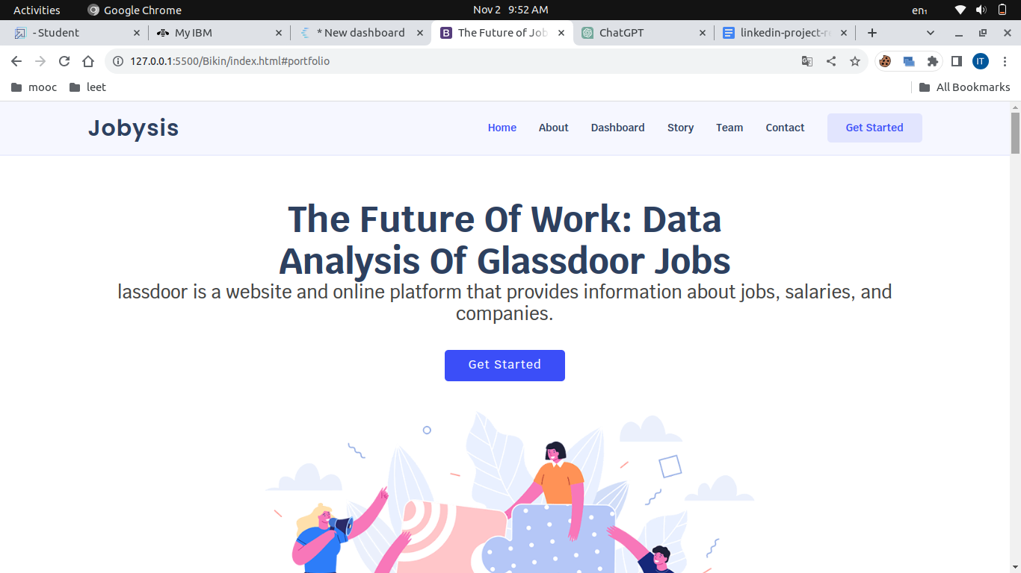

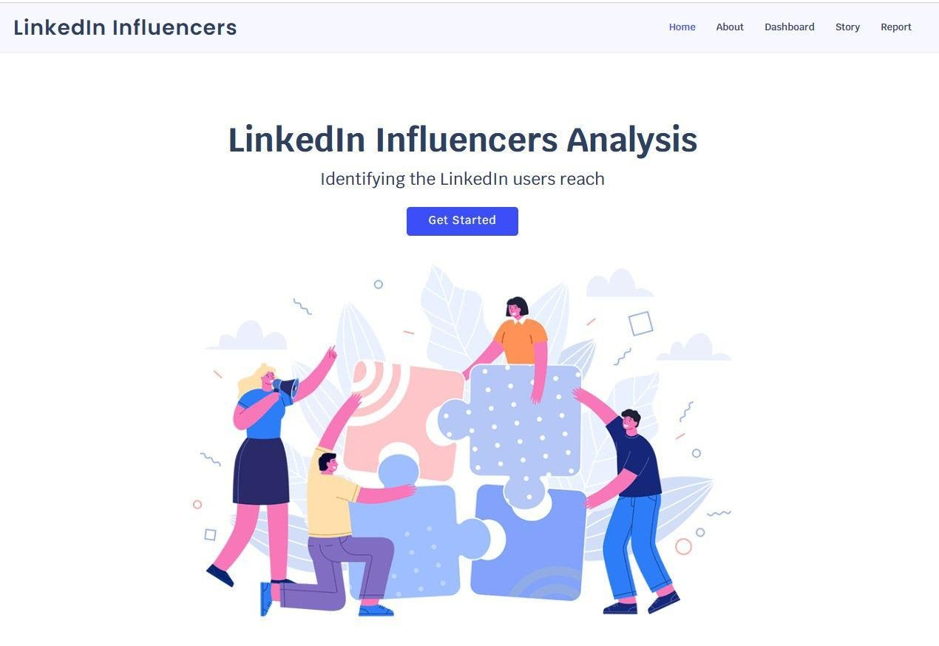

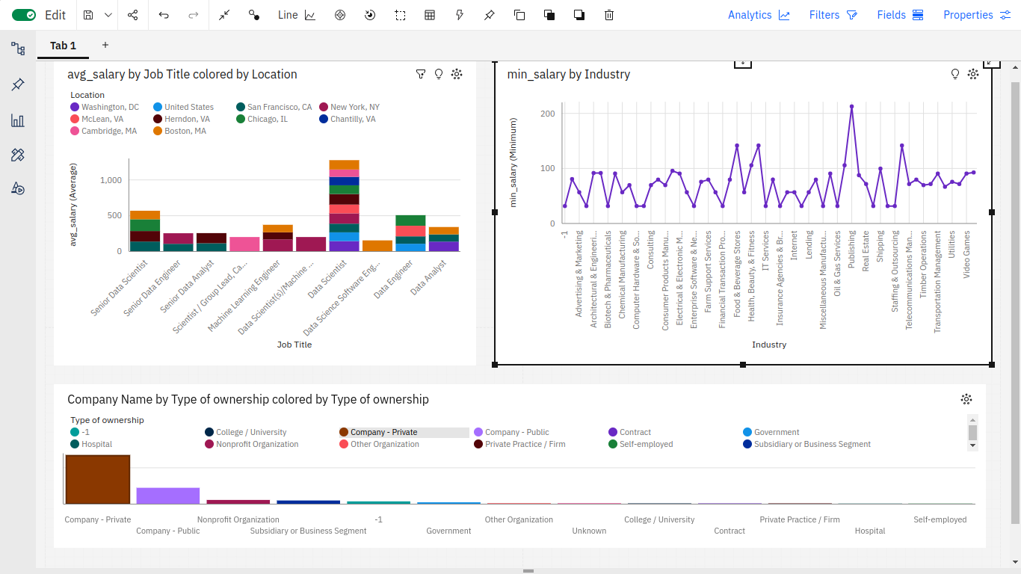

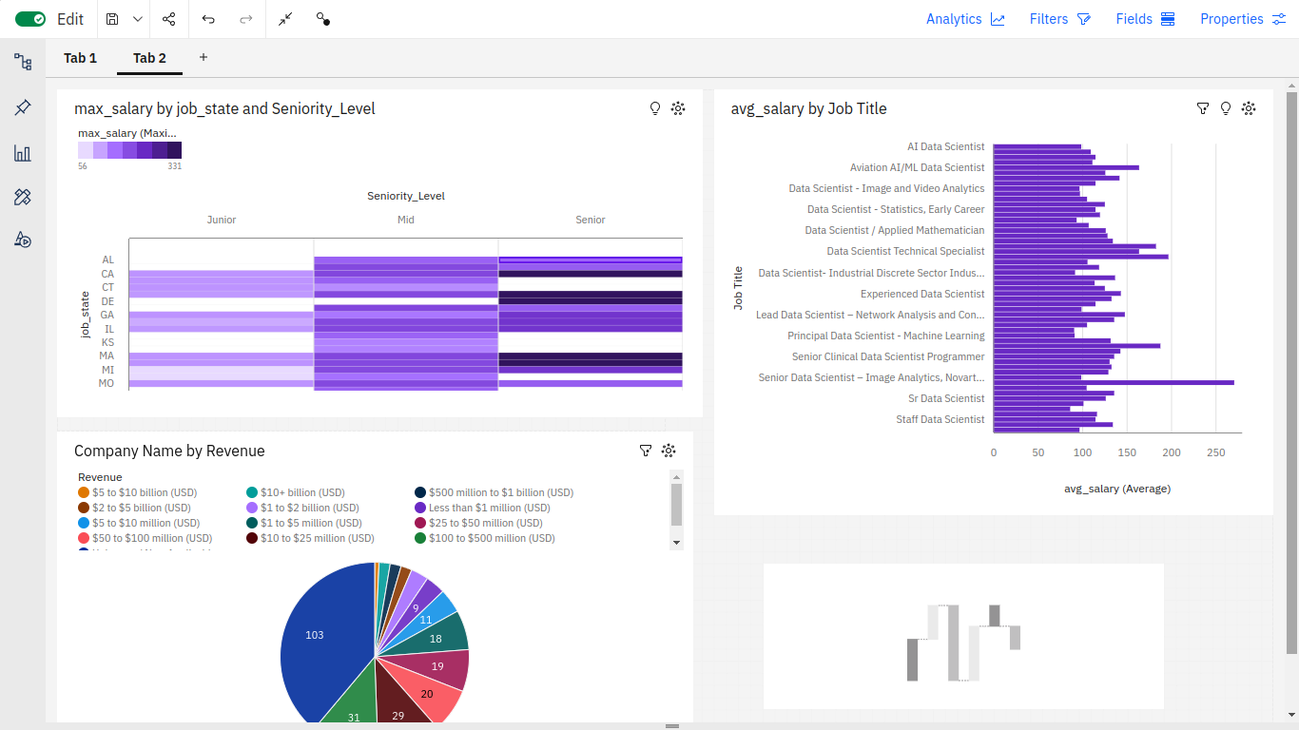

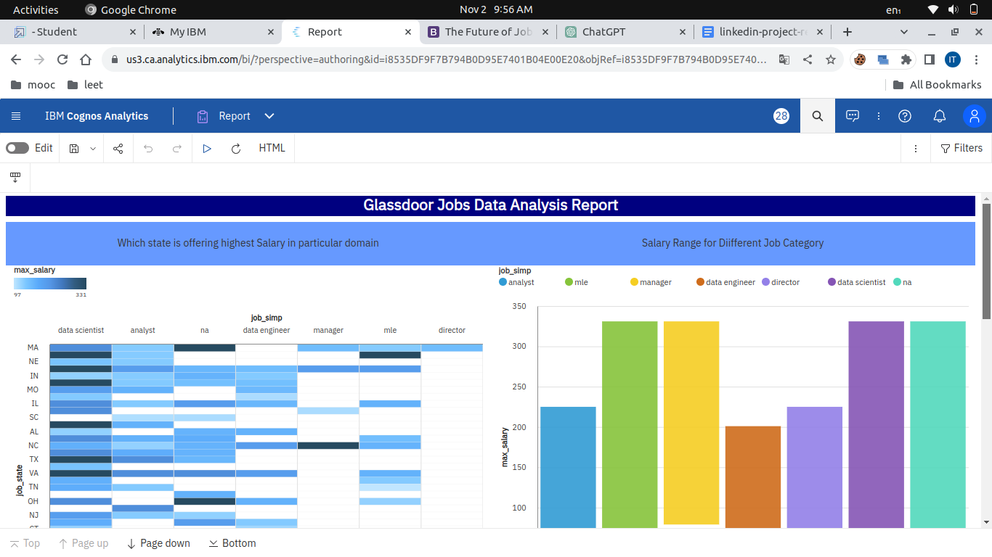

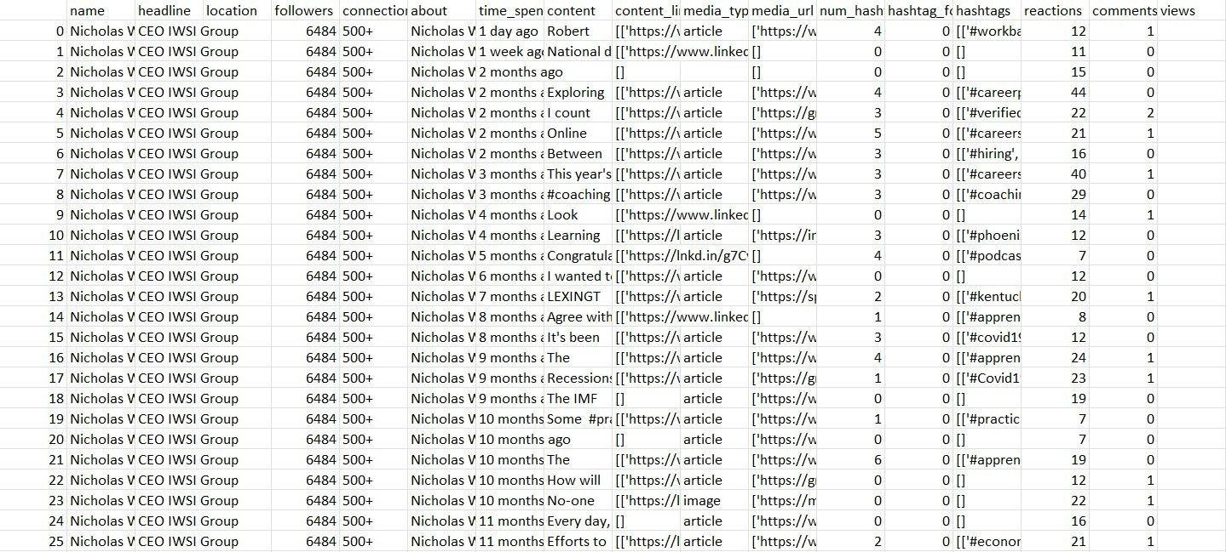

## 10. ADVANTAGES & DISADVANTAGES

### Advantages

| • | Access to industry trends and insights |
| --- | --- |
| • | User-friendly platform |
| • | Real-time updates |

### Disadvantages

| • | Limited to publicly available |
| --- | --- |
| • | Privacy concerns |



## 11. CONCLUSION

This project successfully addressed the challenge of Glassdoor Job Analysis. It provides valuable insights and a user-friendly platform for professionals and organizations to stay informed about their respective industries.

## 12. FUTURE SCOPE

The project's future scope includes:

| • | Expanding to other social networks |
| --- | --- |
| • | Implementing machine learning for trend prediction |
| • | Enhancing user customization |

## 13. APPENDIX

### Source Code

| <https://github.com/SamsudeenSha/The-Future-of-Work-Data-Analysis-of-Glassdoor-Jobs> |  |
| --- | --- |

### GitHub & Project Demo Link

<https://drive.google.com/file/d/14MqJt2YzKJ7wkPfmo6XSweqd4nFVf-pu/view?usp=drive_link>